# General

When the program is started, it will read from a crypkey log file, and format the entries as csv.

It will add all new entries to an existing csv file, or create a new file if the csv file does not already exist.

It compares the last entry in the csv file, and adds all newer entries from the crypkey log.

# Setup

The program have 2 settings that can be modified in the config file.

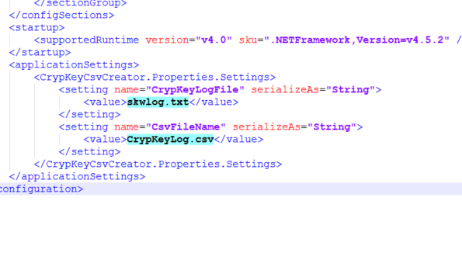

The CrypKeyLogFile is the full path to the crypkey log.

The CsvFileName is the full path to the csv file.

The program must have read permissions to the folder where the crypkey log is located, and full permissions to the folder where the csv file is located.